Reentry: Advancing Social Justice While Forging New College Student Identities in Transitional Places of Incarceration

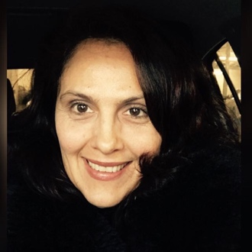

Dr. Franca Ferrari-Bridgers is an assistant professor in the Speech Communication and Theater Arts department at Queensborough Community College. Dr. Ferrari-Bridgers’ research interests are in the field of linguistics, psycholinguistics, listening assessments, pedagogical research and higher education in prison.

Dr. Carolyn D. King is an Assistant Professor in the Mathematics Department at Queensborough Community College. Dr. King studies the under-representation of minorities in Science, Technology, Engineering and Math (STEM).

Dr, Agnieszka Tuszynska is an Assistant Professor of English at Queensborough Community College-CUNY where she teaches African American literature and writing. She has worked as an educational volunteer in prisons and jails in Illinois and New York since 2009.

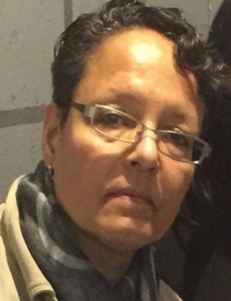

Dr. Rose Marie Äikäs received her PhD from Rutgers University School of Criminal Justice in 2012 under the tutelage of Dr. Bonnie Veysey. Ms. Äikäs has international and domestic prison research experience, professional background as a criminal justice and social work practitioner and as a teacher at graduate school, four year, two your college levels and New York State correctional institution.

