Table 2. Variables Predicting Spring Language and Literacy Skills for EL’s
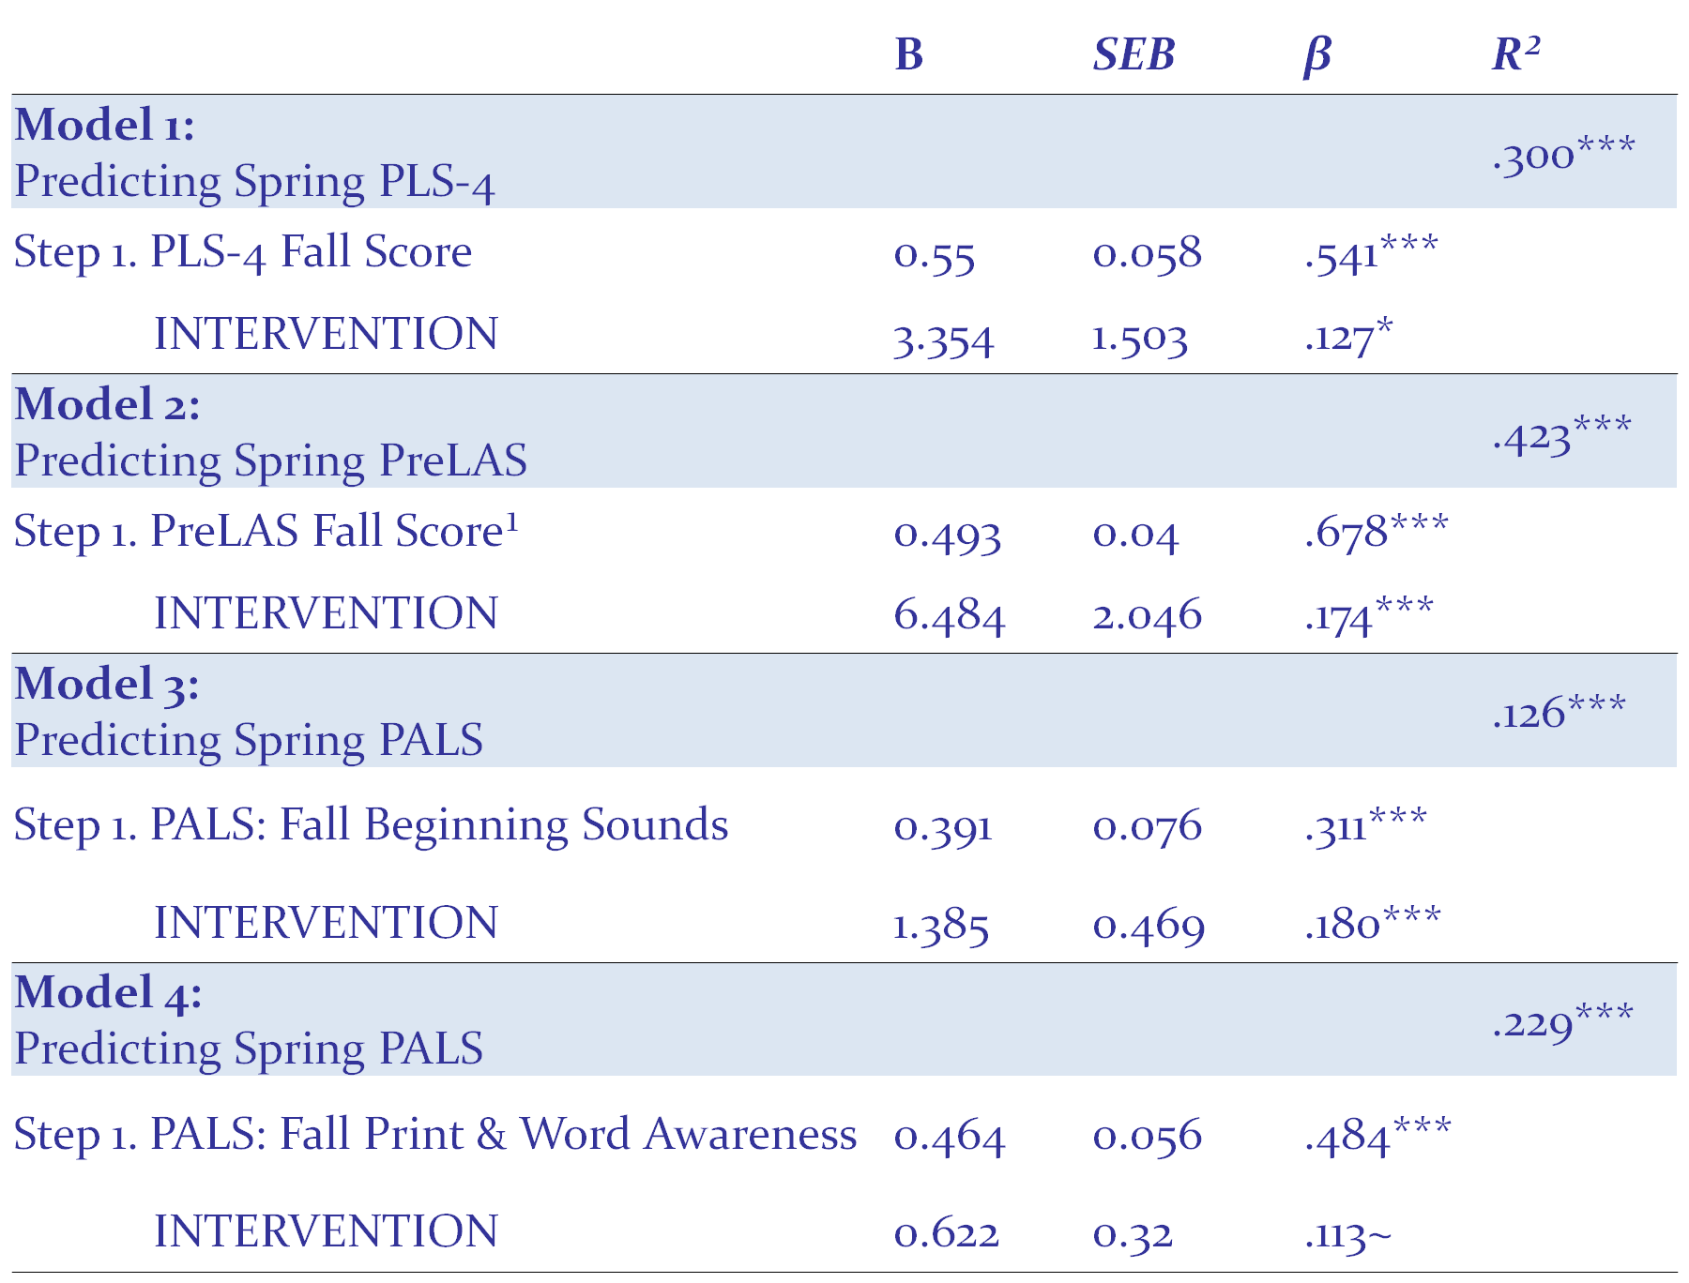
Note. Intervention is the reference variable. ¹Fall PreLAS does not include children scoring proficient in English. *** p < .001, p < .05, ~p = .054

