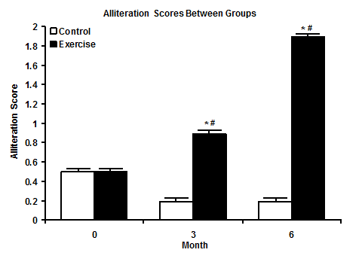
Figure 2. Mean Alliteration scores between groups. Values are means ± SE; *P<0.05 from 0 week within group, # between groups.

